- "What is the capital of France?
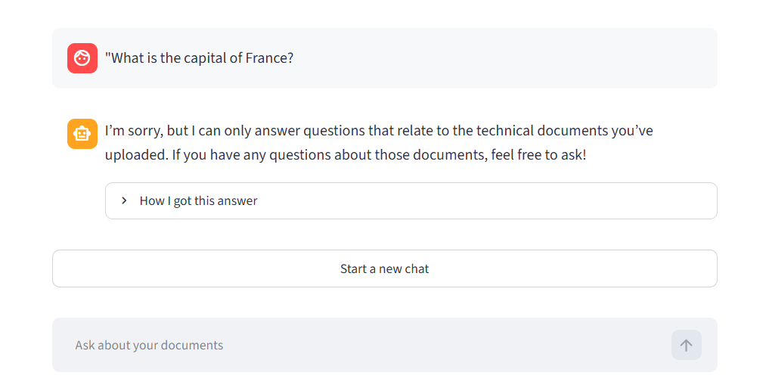

- A harmful question (e.g. asking how to make a weapon)


